**Assignment MT1-2019-5**

**Section 1**

**(Based on Lecture Notes)**

* 1. **)** Explain Two Resistance Theory or Two Film Theory. Why is it called so?
  2. **)** Establish the graphical relationship between local mass transfer coefficients and interfacial concentration in case of inter phase mass transfers.
  3. **)** What is Overall mass transfer coefficients? Why is it necessary to express the molar flux in terms of overall mass transfer coefficient rather than local mass transfer coefficients? How many ways can you define overall mass transfer coefficients ?
  4. **)** Establish the relationship between local and overall mass transfer coefficients.
  5. **)** Derive and represent graphically operating line equations for

**a)** Co-current steady state continuous contact process.

**b)** Counter-current steady state continuous contact process.

**c)** Cross-current steady state contact process.

* 1. **)**Define stages. Derive and represent graphicallyoperating line equations for stage wise countercurrent steady state process
  2. What is the name of the equation used to determine the number of ideal stages in stage wise countercurrent steady state operation. Write down the equation.

**Section-2**

**(Based on the worked out problems in the text book)**

**From book: Principle of Mass Transfer by B.K.Dutta**

**2.1)** Example 4.1 page no-133

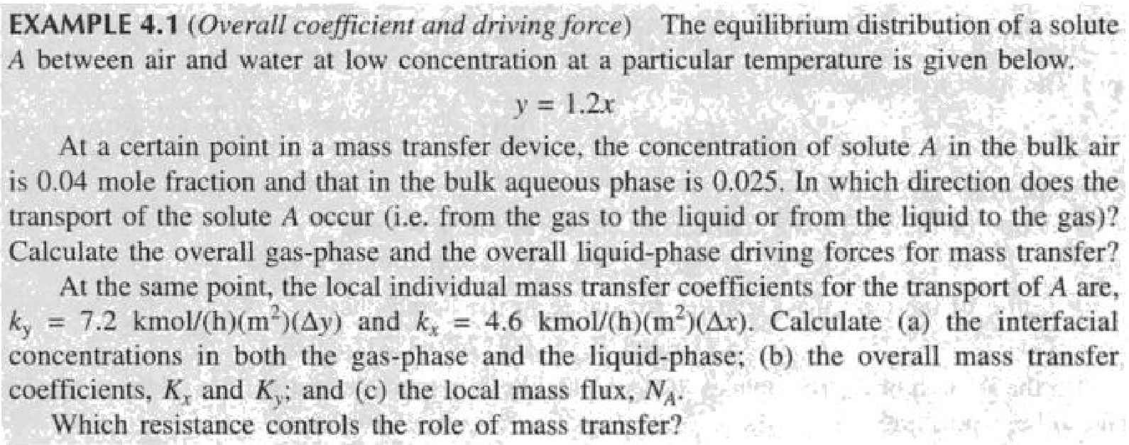

**2.2)** Example 4.2 page no-134

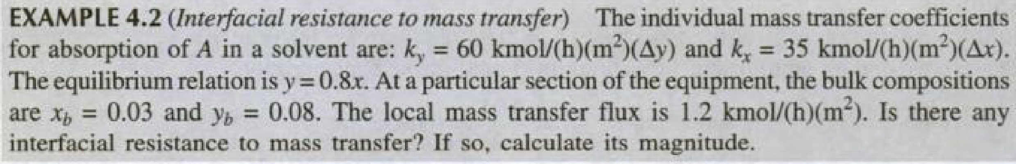

**2.3)** Example 4.3 page no-134

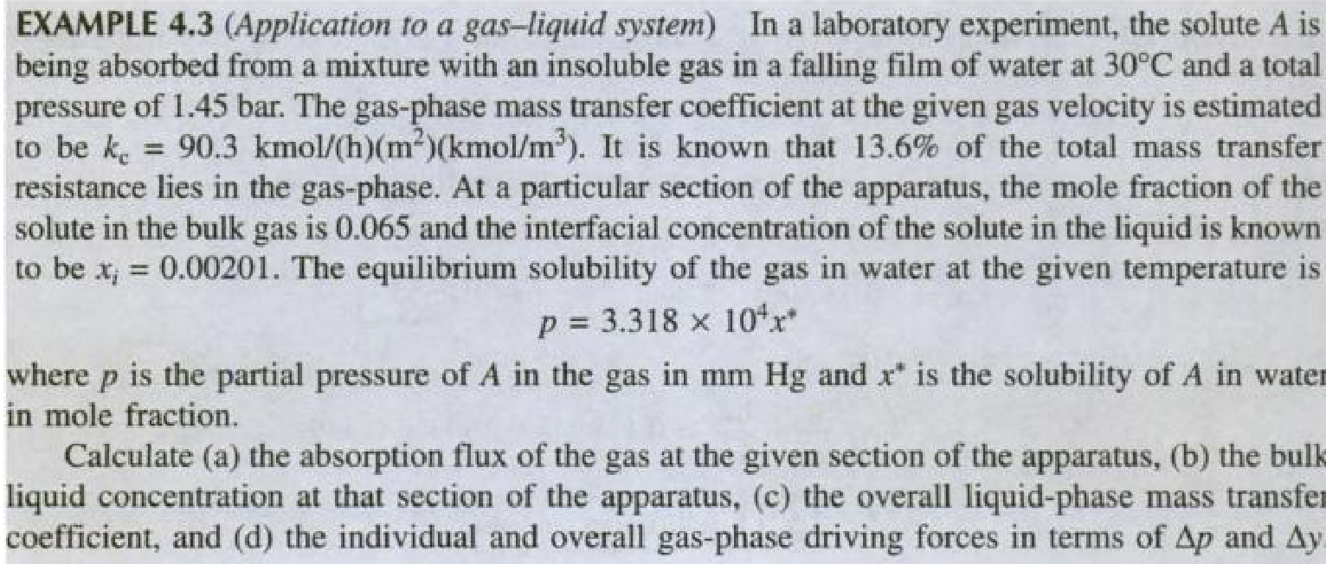

**2.4)** Example 4.4 page no-136

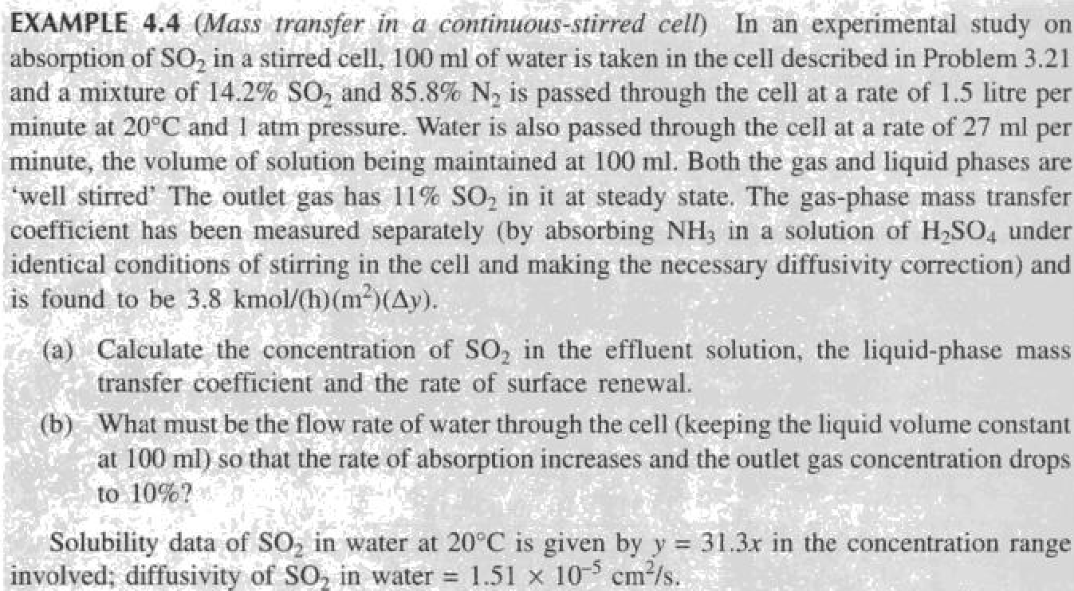

**2.5)** Example 4.5 page no-137

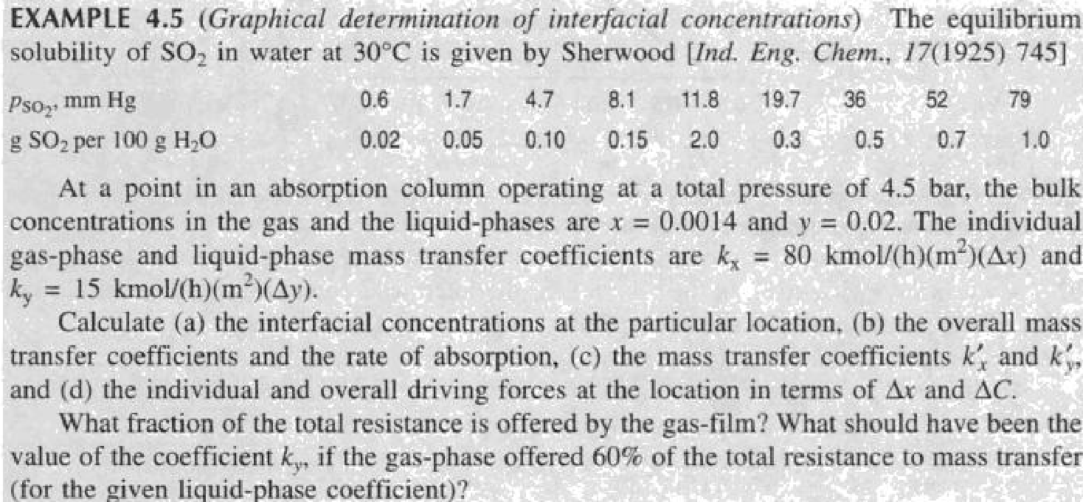

**2.6)** Example 4.6 page no-148

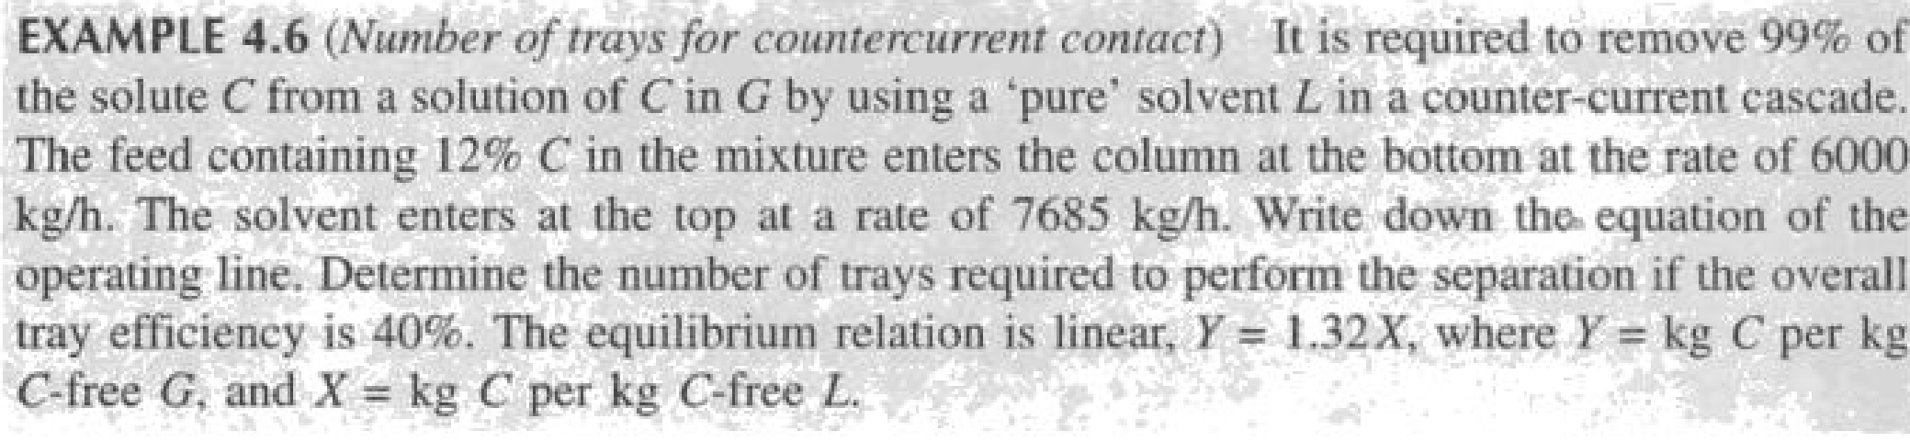

**2.7)** Example 4.7 page no-151

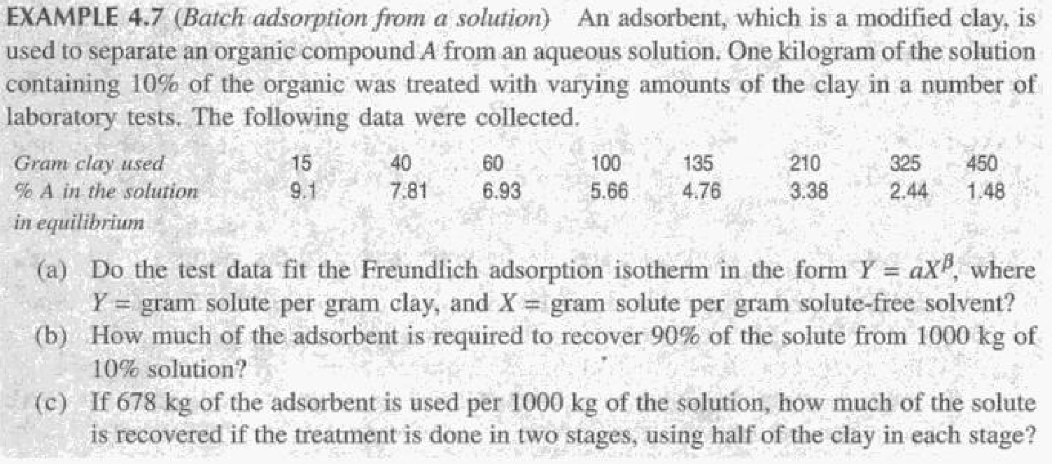

**Section 3**

**Unsolved Problems**

3.1

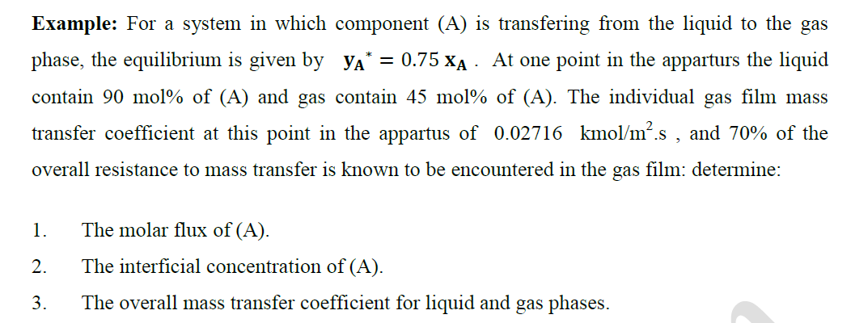

3.2

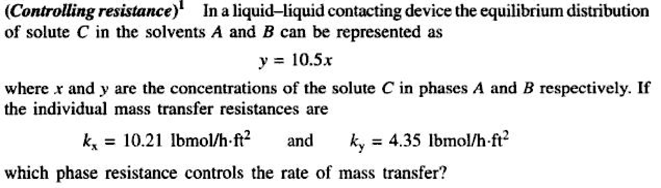

**3.3**

**In an experimental study of the absorption of ammonia by water in a wetted-wall column, the value of overall mass transfer coefficient, KG was found to be 2.75 10-6 kmol/m2 -s-kPa. At one point in the column, the composition of the gas and liquid phases were 8.0 and 0.115 mole% NH3, respectively. The temperature was 300K and the total pressure was 1 atm. Eighty five % of the total resistance to mass transfer was found to be in the gas phase. At 300 K, Ammonia –water solutions follows Henry’s law upto 5 mole% ammonia in the liquid, with m = 1.64 when the total pressure is 1 atm. Calculate the individual film coefficients and the interfacial concentrations. Interfacial concentrations lie on the equilibrium line.**